**Program for Visualization of time series data:**

### **Aim:**

To develop a program that visualizes time series data using appropriate graphs such as line charts, scatter plots, and bar charts, enabling users to identify trends, seasonality, and anomalies effectively.

**Algorithm:**

1. **Load the dataset** from a file or database.

2. **Convert the time column** to a datetime format.

3. **Handle missing values** using interpolation or forward-fill.

4. **Resample data** if needed (e.g., daily to monthly).

5. **Plot a line graph** to visualize trends.

6. **Compute and plot a rolling mean** to smooth fluctuations.

7. **Plot a scatter plot** to identify anomalies.

8. **Perform seasonal decomposition** if required.

9. **Enhance visualization** with labels, titles, and legends.  
10. **Use interactive plots** for better exploration..

**1. Importing Libraries :**

import seaborn as sns

import matplotlib.pyplot as plt

import pandas as pd

import numpy as np

seaborn: A powerful visualization library built on top of matplotlib. It provides more aesthetic and informative plots like scatterplots, boxplots, and heatmaps.

matplotlib: A widely used library for creating static, interactive, and animated visualizations in Python.

pandas: A library for data manipulation and analysis. It introduces the DataFrame object, which is particularly suited for working with structured data (like CSV files or databases).

numpy: A library for numerical computations. It’s frequently used alongside pandas for handling mathematical operations on large datasets.

]

### **2. Loading the Dataset** :

file_path="D:/221501124/OzoneHole_Data.csv"

df=pd.read_csv(file_path)

**3. Scatter Plot - Ozone Hole Area vs. Minimum Ozone:**

**plt.figure(figsize=(10,5))**

**sns.scatterplot(x=df['Hole Area'],y=df['Minimum Ozone'],hue=df['Year'])**

**plt.xlabel("Ozone Hole Area")**

**plt.ylabel("Minimum Ozone")**

**plt.title("Ozone Hole Area vs Minimum Ozone")**

**plt.show()**

sns.scatterplot creates a scatter plot, where:

* The x-axis (df["Hole Area"]) represents the ozone hole area.
* The y-axis (df["Minimum Ozone"]) represents the minimum ozone concentration.
* The hue=df["Year"] colors the points based on the year, helping to observe trends over time.
* The palette="viridis" applies a color gradient that improves visibility of year-wise variations.

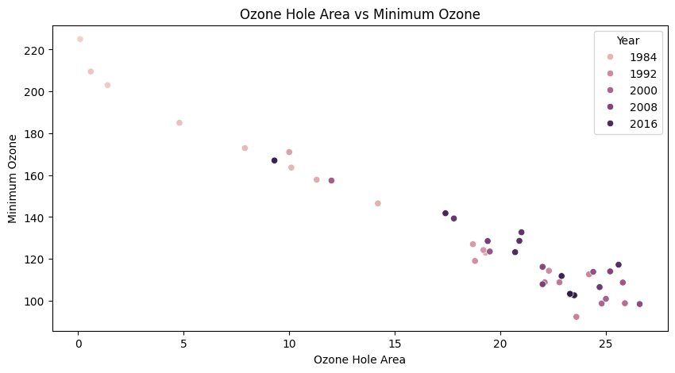

**4. Bar Plot - Ozone Hole Area by Year:**

**plt.figure(figsize=(10,5))**

**sns.boxplot(x=df['Hole Area'],y=df['Minimum Ozone'],palette='Blues')**

**plt.ylabel("Ozone hole Area ")**

**plt.xlabel("Year")**

**plt.title("Annual Ozone Hole Area")**

**plt.grid(True)**

**plt.show()**

* sns.boxplot() creates a box plot, where:
  + x-axis (df["Hole Area"]) – Represents the ozone hole area (but this should ideally be a categorical variable like "Year").
  + y-axis (df["Minimum Ozone"]) – Represents the minimum ozone concentration.
  + palette="Blues" – Uses a blue color scheme for the box plot

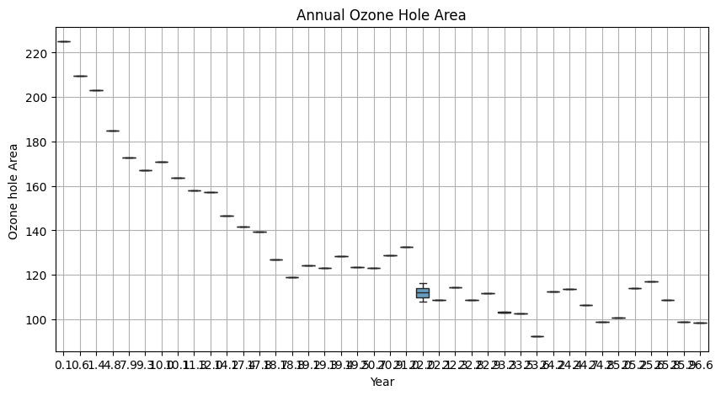

**5. Histogram - Distribution of Minimum Ozone:**

**plt.figure(figsize=(12,6))**

**sns.histplot(df['Minimum Ozone'],bins=10,color='green')**

**plt.xlabel("Minimum Ozone Level")**

**plt.ylabel("Frequency")**

**plt.title("Distribution of Minimum Ozone Levels")**

**plt.grid(True)**

sns.histplot() creates a histogram, which shows the distribution of a numerical variable.

df["Minimum Ozone"] is the data being plotted, which represents the minimum ozone levels recorded.

bins=10 divides the data into 10 intervals, grouping similar values together.

kde=True (Kernel Density Estimation) adds a smooth curve over the bars to show the probability distribution.

color="green" sets the histogram bars to green.

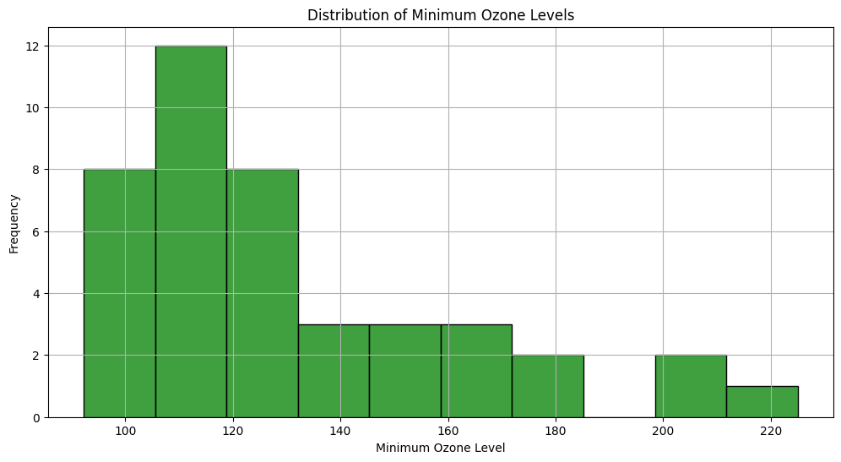

**6. Box Plot - Ozone Hole Area Distribution:**

**plt.figure(figsize=(6, 5))**

**sns.boxplot(y=df["Hole Area"], color="orange")**

**plt.ylabel("Ozone Hole Area")**

**plt.title("Ozone Hole Area Distribution")**

**plt.grid(True)**

**plt.show()**

sns.boxplot() creates a box plot, which visualizes the distribution of the "Hole Area" (ozone hole size).

The y-axis represents ozone hole area.

The color="orange" sets the box plot to orange for better visibility.

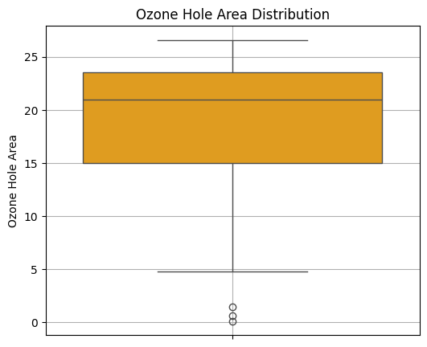

**7.Rolling Average Plot - 5-Year Trend of Ozone Hole Area:**

**df["Rolling_Hole_Area"] = df["Hole Area"].rolling(window=5, min_periods=1).mean()**

**plt.figure(figsize=(10, 5))**

**sns.lineplot(x=df["Year"], y=df["Rolling_Hole_Area"], color="purple")**

**plt.xlabel("Year")**

**plt.ylabel("5-Year Rolling Average")**

**plt.title("5-Year Rolling Average of Ozone Hole Area")**

**plt.grid(True)**

**plt.show()**

* rolling(window=5, min_periods=1).mean() calculates a 5-year rolling average of the Ozone Hole Area.
  + window=5 → Uses the last 5 years' data to calculate the average.
  + min_periods=1 → Ensures that for the first few years (where less than 5 data points are available), it still computes an average using the available values.

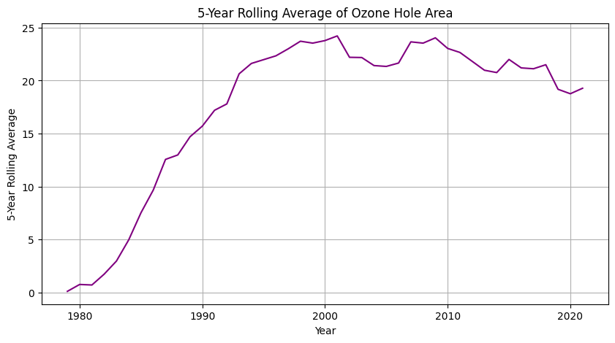

**8.RESULT:**

Thus successfully implemented a program related to Visualization of ozone depletion dataset .